# SFCG Nigeria uses FrontlineSMS to create a conflict Early Warning System

Posted by [Valerie Oliphant](http://www.frontlinesms.com/author/valeriefrontlinesms-com/) on 13 August 2014

After successfully using FrontlineSMS in the [Tomorrow is a New Day (TND)](http://www.tomorrowisanewday.org/) project to monitor and improve radio dramas in the Niger Delta, [SFCG Nigeria](http://sfcg.org/programmes/nigeria/index.html) chose to use the platform in a completely different capacity in Jos, a city in Northern Nigeria. [SFCG Nigeria](http://sfcg.org/programmes/nigeria/index.html) is part of [Search for Common Ground](https://www.sfcg.org/), one of the first and largest conflict resolution focused NGOs. In Northern Nigeria, SFCG partnered with Community Action for Popular Participation (CAPP) to develop an Early Warning System (EWS) funded by the US Institute for Peace (USIP).

SMS and emails have been used to spread rumors and inflammatory messages at terrifying speeds in Nigeria, exacerbating tensions. In order to empower local communities to respond, an EWS was developed to provide timely and accurate information to the Plateau Peace Practitioners Network (PPPN)[1] and Operation Rainbow, using FrontlineSMS, Ushahidi’s CrowdMap, and 109 focal points drawn from eight Local Government Areas (LGAs) in Plateau State.[2]

The 109 focal points were comprised of trusted community leaders and representatives, who were then trained in using SMS to submit reports on peace and violence in their areas as part of a bounded-crowd approach to crowdsourcing. These SMS reports were collected using FrontlineSMS, and used to create bulletins and monthly reports, and to inform SFCG’s *Voices of Peace* Radio Program, in order to discredit inflammatory rumors.

While FrontlineSMS can be used to receive and store SMS, it can also be used as a cost-effective and simple way to send SMS Blasts- mass texts that go out to a group of subscribed users or members that have been input into a cell phone database. SMS blasts were used to encourage the public to regularly submit reports and rumors, as well as to distribute messages of peace. According to an [internal evaluation](http://www.sfcg.org/programmes/ilt/evaluations/NGR_EV_Nov13_Participatory%2520Early%2520Warning%2520for%2520More%2520Effective%2520Response%2520to%2520Religious%2520Conflict%2520in%2520Plateau%2520State.pdf), “the SMS Blasts were one of the most successful components of the program because they helped keep the public alert and engaged in the program.” Subscribers received up to 2 blasts per week, depending on the frequency of violence in their area. Focus group participants had saved these blasts in their phones, expressed a desire to increase the frequency of blasts, and reported that the blasts gave them a sense of ownership of peace. For example, one user said the blasts had made him feel it was his personal responsibility to bring stability to his area.

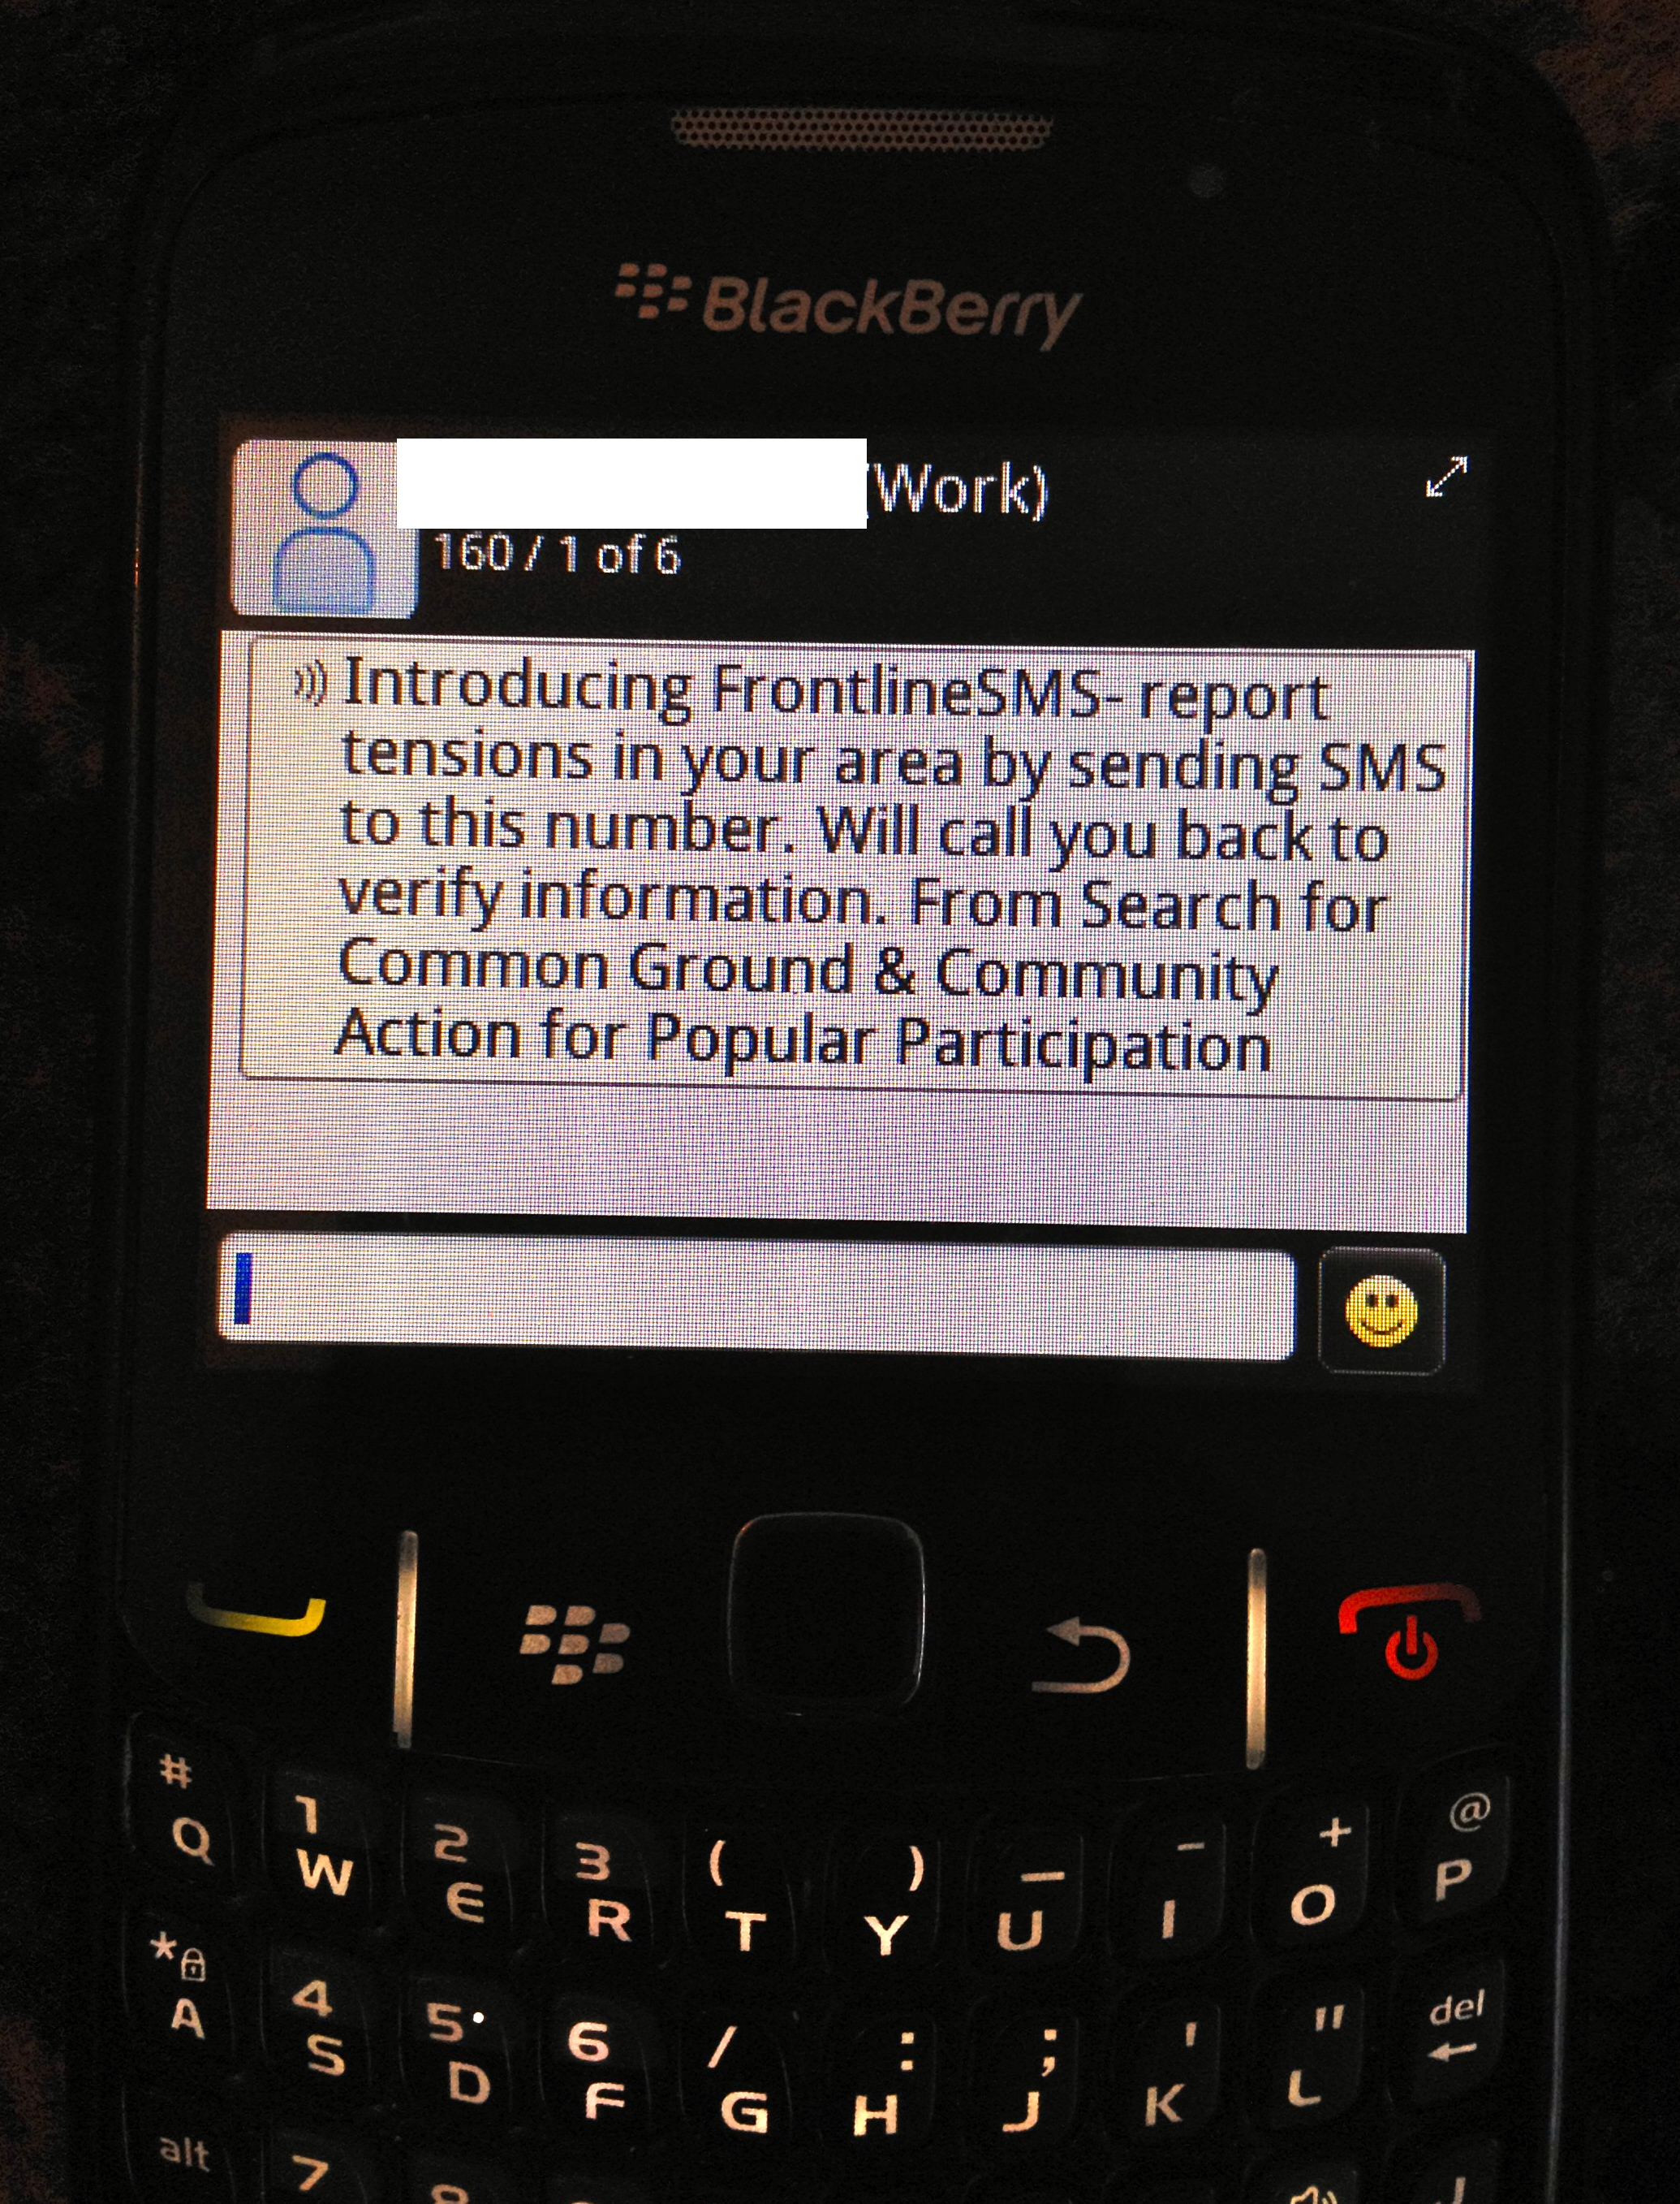

When looking at access and affordability, SFCG Nigeria found that designated focal points, as well as the general public, were motivated to send in SMS reports without monetary compensation or other incentives, and felt that contributing to peace and stability in their community was incentive enough. Individuals found the SMS system easy to use, and focal points working in areas with illiterate populations were able to serve as an intermediary between the population and the platform, sending in SMS reports based on phone calls they received from those unable to text.

However, unreliable network coverage limited participation from the general public. Focal points and community members reported that the messages they sent into the FrontlineSMS system had bounced back or were not received by SFCG despite being confirmed as delivered in their phone. Moreover, focal points and SFCG/CAPP noted that security forces often intentionally shut down cell phone networks during times of crisis. This decreases the effectiveness of the EWS: community members are unable to report incidents in real time; SFCG/CAPP are unable to report incidents for rapid response; it confuses the public and creates apathy about using the EWS; and it could create mistrust if community members believe security institutions are monitoring their SMS.

Since the EWS project has been extended with the sponsorship of the EU, SFCG and CAPP are adopting the following recommendations and lessons learned from their internal evaluation:

1. Conduct a larger and more strategic outreach campaign to engage the general public.
2. Keep a back-up record of all SMS in a separate Excel Database to support increased data storage, avoid loss of data, and enable data analysis.
3. Since users had not been using the [online CrowdMap platform](https://frontlinesmsplateaustate.crowdmap.com/main), the maps are now used in the monthly EWS bulletins, which are circulated in the eight LGAs among key government officials, local leaders, community members, security and the university community. Soft copies are emailed to key stakeholders.
4. Leverage the success of SMS blasts to impact not only what messages people send, but how they behave during crises.
5. Conduct strategic data analysis for SMS messages by coding messages using a more comprehensive list of variables and a more complex analysis in order to improve program implementation and utility.

SFCG Nigeria will continue to use FrontlineSMS to advertise other media programs, send peace messages via SMS Blasts, and as a listenership and viewership hotline number for their media programs.

1. The Plateau Peace Practitioners Network (PPPN), a coalition of 60 interfaith peacebuilding groups working to prevent violence and resolve conflicts in Northern Nigeria
2. Jos North, Jos South, Jos East, Bassa, Riyom, Barkin-Ladi, Mangu, and Wase LGAs.